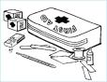
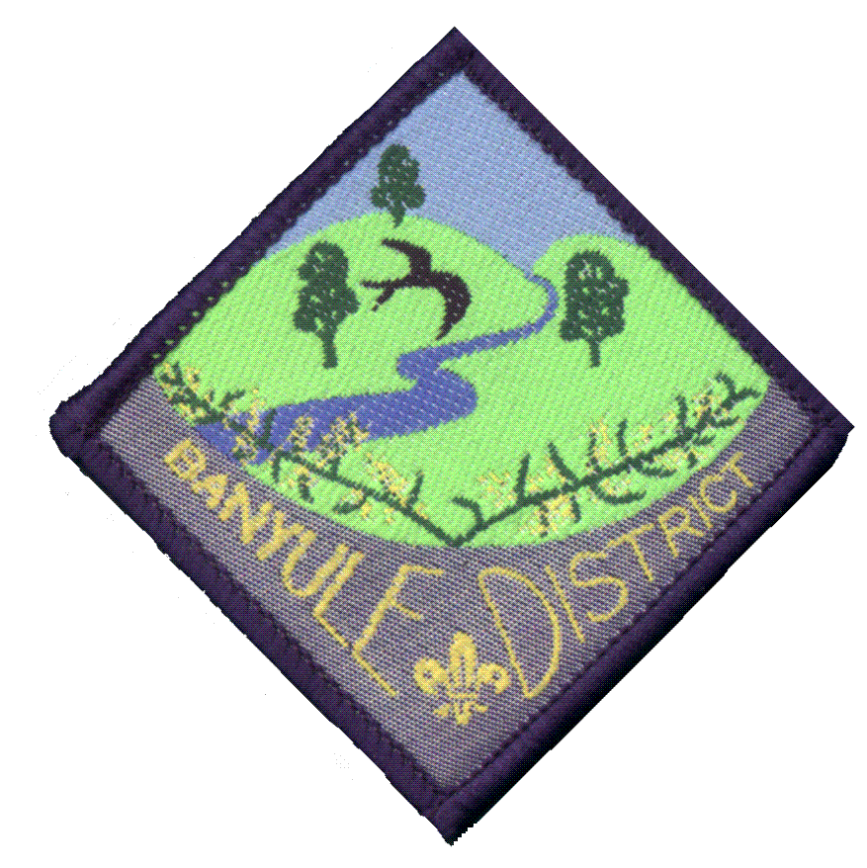
Banyule District Cub Scouts
First Aid Camp
13th – 14th June 2009

What is the First Aid camp?
The Camp is for the senior Cubs to gain further knowledge of first aid.
- Understand DRABC
Cost of $20.00 per Cub

- Put someone into the recovery position
- Treat a bleeding wound
- Learn about snake bites
The Camp starts Saturday 10am
Finishing around 2pm on Sunday

- Learn about spider/ insects bites
- Use of Phones in an emergency
All this information is available on Page 94 of your Yellow Book.

Meet at 1st Ivanhoe Sea Scout Hall, Norman Street Ivanhoe,
in full uniform, for a 10 o’clock start.

You will need to bring
Sleeping Gear Sleeping bag and Pillow and Stretcher/mat/lilo
Clothes 2 changes, warm jumper, hat, waterproof coat
Sundries Toilet bag, Dilly Bag with plate, bowl and cup and cutlery, tea towel, torch, and Insect Repellent
Must bring a Personal First Aid Kit

Cut off bottom portion of permission slip and return to Akela next week (9th June).

I give permission for my child:
of Rosanna Cubs
Name

To attend First Aid Camp on 13th to 14th June 2009

Special Instructions (food/allergies/medical):

Enclosed is $20.00. Method of payment: _______cash ________ cheque
Note: Please make cheques payable to the Banyule District Cub Scouts.

X
Parent or guardian signature Date

Banyule District Cub Scout Leaders Activity Team

